

AI PROJECT REPORT

SECTION : CSE-22
SUBJECT : AI

PREPARED BY :
DEEPANSHU SINGH BAGHEL
ROLL NO. - 2305854

#Abstract
The Water Jug Puzzle Game is an interactive graphical application that showcases the classic Water Jug Problem using Python and the Tkinter GUI framework. The objective is to measure a specific quantity of water using two jugs with fixed capacities. Players perform actions like filling, emptying, and pouring water between the jugs. This project combines problem-solving with an easy-to-use graphical interface.

#Problem Statement
You have two water jugs with fixed capacities and an unlimited water source. The goal is to measure a specific target quantity of water. Players can perform three actions: fill a jug completely, empty a jug, or pour water from one jug into another. The challenge lies in reaching the exact target amount through logical steps.

#Core Features
• Full-screen responsive graphical interface built with Tkinter
• Interactive jugs with animated water levels
• Smooth water pouring animation between jugs
• Multiple puzzle levels that increase in difficulty
• Level completion screen with a Next Level option
• Hint System based on Breadth-First Search (BFS)
• Real-time display of jug capacity, target value, and timer

#Technologies Used
Programming Language: Python
GUI Framework: Tkinter
Algorithm: Breadth-First Search (BFS) for hint generation
Concepts Used: State-Space Search, Animation, Event Handling, Responsive UI Layout.

#Application Workflow
1. The player starts at Level 1 with two jugs of defined capacities.
2. The user selects a jug and performs actions like Fill, Empty, or Pour.
3. The game visually updates the water level in the jugs with smooth animation.
4. The system checks if the target water quantity has been met.
5. If the target is reached, a Level Completed screen appears, allowing the user to move to the next level.
6. The Hint system can suggest the next best move to the player.

#Algorithm Explanation (Hint System)
The application uses a Breadth-First Search (BFS) algorithm to generate hints. Each state shows the amount of water in Jug 1 and Jug 2. From each state, possible actions (fill, empty, pour) create new states. BFS explores these states level by level until it finds one that contains the target amount. The first step of that solution path is shown to the player as a hint.

#Future Improvements
• Add an animated water stream between jugs during pouring
• Introduce more levels with larger jug capacities
• Add sound effects and visual effects
• Implement score tracking and a leaderboard
• Convert the project into a mobile application using frameworks like Flutter or React Native

#Code for referance

import tkinter as tk
import time
import math
from collections import deque

class RealisticJugGame:

def __init__(self, root):

self.root = root
self.root.title("Realistic Water Jug Game")
self.root.state("zoomed")

self.levels = [
{"cap1":4,"cap2":3,"target":2},
{"cap1":5,"cap2":7,"target":6},
{"cap1":8,"cap2":5,"target":4},
]

self.level_index = 0
self.level_completed = False
self.load_level()

self.selected=None
self.score=0
self.start_time=time.time()
self.wave_phase=0
self.is_pouring=False

# ⭐ NEW HINT STORAGE
self.hint_text=""

self.canvas=tk.Canvas(root,bg="#0b1020",highlightthickness=0)
self.canvas.pack(fill="both", expand=True)

self.info=tk.Label(root,font=("Segoe UI",12),bg="#0b1020",fg="white")
self.info.pack()

frame=tk.Frame(root,bg="#0b1020")
frame.pack(pady=8)

tk.Button(frame,text="Fill",width=8,command=self.fill_selected).pack(side="left",padx=5)
tk.Button(frame,text="Empty",width=8,command=self.empty_selected).pack(side="left",padx=5)
tk.Button(frame,text="Reset",width=8,command=self.reset).pack(side="left",padx=5)
tk.Button(frame,text="💡 Hint",width=8,command=self.show_hint).pack(side="left",padx=5)

self.next_btn=tk.Button(frame,text="Next Level ▶",width=12,
command=self.next_level,
bg="#2ecc71",fg="black")
self.next_btn.pack(side="left",padx=10)
self.next_btn.pack_forget()

self.canvas.bind("<Button-1>",self.click_jug)
self.root.bind("<Configure>", self.on_resize)

self.update_ui()
self.animate()

def load_level(self):
lvl=self.levels[self.level_index]
self.cap1=lvl["cap1"]
self.cap2=lvl["cap2"]
self.target=lvl["target"]

self.logic_j1=0
self.logic_j2=0

self.j1=0.0
self.j2=0.0

def on_resize(self,event):
self.update_ui()

def draw(self):
self.canvas.delete("all")

w=self.canvas.winfo_width()
h=self.canvas.winfo_height()

center_x=w//2
left_x=center_x-120
right_x=center_x+120

self.left_x=left_x
self.right_x=right_x

self.draw_jug(left_x,self.j1,self.cap1,1)
self.draw_jug(right_x,self.j2,self.cap2,2)

self.canvas.create_text(left_x,h-60,
text=f"{self.logic_j1} / {self.cap1}",
fill="white",
font=("Segoe UI",13,"bold"))

self.canvas.create_text(right_x,h-60,
text=f"{self.logic_j2} / {self.cap2}",
fill="white",
font=("Segoe UI",13,"bold"))

if self.level_completed:
self.canvas.create_rectangle(0,0,w,h,fill="#000000",stipple="gray50")
self.canvas.create_text(w//2,h//2,
text="LEVEL COMPLETED!",
fill="#00ffcc",
font=("Segoe UI",26,"bold"))

def draw_jug(self,x,amount,cap,jug_id):

top=120
base=self.canvas.winfo_height()-100
w=40

self.canvas.create_rectangle(x-w,top,x+w,base,
outline="#9fbaff",width=3)

if self.selected==jug_id:
self.canvas.create_rectangle(x-w-5,top-5,x+w+5,base+5,
outline="red",width=2)

self.draw_water(x-w,x+w,amount,cap,top,base)

def draw_water(self,x1,x2,amount,cap,top,base):

if amount<=0: return

height=(amount/cap)*(base-top)
top_y=base-height

margin=3
x1+=margin
x2-=margin

pts=[]
for x in range(int(x1),int(x2)+1,4):
wave=4*math.sin((x*0.05)+self.wave_phase)
y=top_y+wave

if y<top: y=top
if y>base: y=base

pts.append((x,y))

poly=[]
for p in pts:
poly.append(p[0]); poly.append(p[1])

poly.append(x2); poly.append(base)
poly.append(x1); poly.append(base)

self.canvas.create_polygon(poly,fill="#52d6ff",outline="")

def click_jug(self,event):

if self.level_completed or self.is_pouring:
return

x,y=event.x,event.y
h=self.canvas.winfo_height()

if self.left_x-40 < x < self.left_x+40 and 120 < y < h-100:
self.handle_selection(1)

elif self.right_x-40 < x < self.right_x+40 and 120 < y < h-100:
self.handle_selection(2)

def handle_selection(self,j):

# ⭐ clear hint when user acts
self.hint_text=""

if self.selected is None:
self.selected=j
else:
if self.selected!=j:
self.animate_pour(self.selected,j)
self.selected=None
self.update_ui()

def fill_selected(self):
self.hint_text=""
if self.selected==1:
self.logic_j1=self.cap1
self.j1=float(self.cap1)
elif self.selected==2:
self.logic_j2=self.cap2
self.j2=float(self.cap2)
self.update_ui()

def empty_selected(self):
self.hint_text=""
if self.selected==1:
self.logic_j1=0
self.j1=0
elif self.selected==2:
self.logic_j2=0
self.j2=0
self.update_ui()

def reset(self):
self.load_level()
self.hint_text=""
self.update_ui()

def animate_pour(self,f,t):

if f==1:
transfer=min(self.logic_j1,self.cap2-self.logic_j2)
else:
transfer=min(self.logic_j2,self.cap1-self.logic_j1)

if transfer<=0: return

self.is_pouring=True

steps=25
flow=transfer/steps

def step():
nonlocal steps

if steps>0:

if f==1:
self.j1-=flow
self.j2+=flow
else:
self.j2-=flow
self.j1+=flow

steps-=1
self.update_ui()
self.root.after(20,step)
else:
if f==1:
self.logic_j1-=transfer
self.logic_j2+=transfer
else:
self.logic_j2-=transfer
self.logic_j1+=transfer

self.j1=float(self.logic_j1)
self.j2=float(self.logic_j2)

self.is_pouring=False
self.check_win()

step()

def show_hint(self):

start=(self.logic_j1,self.logic_j2)
target=self.target
cap1=self.cap1
cap2=self.cap2

visited=set()
q=deque()
q.append((start,[]))

while q:
(a,b),path=q.popleft()

if a==target or b==target:
if path:
self.hint_text=f"💡 Hint: {path[0]}"
self.update_ui()
return

if (a,b) in visited: continue
visited.add((a,b))

moves=[
((cap1,b),"Fill Jug 1"),
((a,cap2),"Fill Jug 2"),
((0,b),"Empty Jug 1"),
((a,0),"Empty Jug 2"),
]

t=min(a,cap2-b)
moves.append(((a-t,b+t),"Pour Jug 1 → Jug 2"))

t=min(b,cap1-a)
moves.append(((a+t,b-t),"Pour Jug 2 → Jug 1"))

for nxt,move in moves:
q.append((nxt,path+[move]))

def check_win(self):
if self.logic_j1==self.target or self.logic_j2==self.target:
self.level_completed=True
self.next_btn.pack(side="left",padx=10)
self.update_ui()

def next_level(self):
self.level_completed=False
self.next_btn.pack_forget()
self.level_index=(self.level_index+1)%len(self.levels)
self.load_level()
self.update_ui()

def update_ui(self):
self.draw()
elapsed=int(time.time()-self.start_time)

base_text=f"Level:{self.level_index+1} Target:{self.target} Time:{elapsed}s"

if self.hint_text:
base_text+=" | "+self.hint_text

self.info.config(text=base_text)

def animate(self):
self.wave_phase+=0.12
self.draw()
self.root.after(30,self.animate)

root=tk.Tk()
game=RealisticJugGame(root)
root.mainloop()

#Pictures

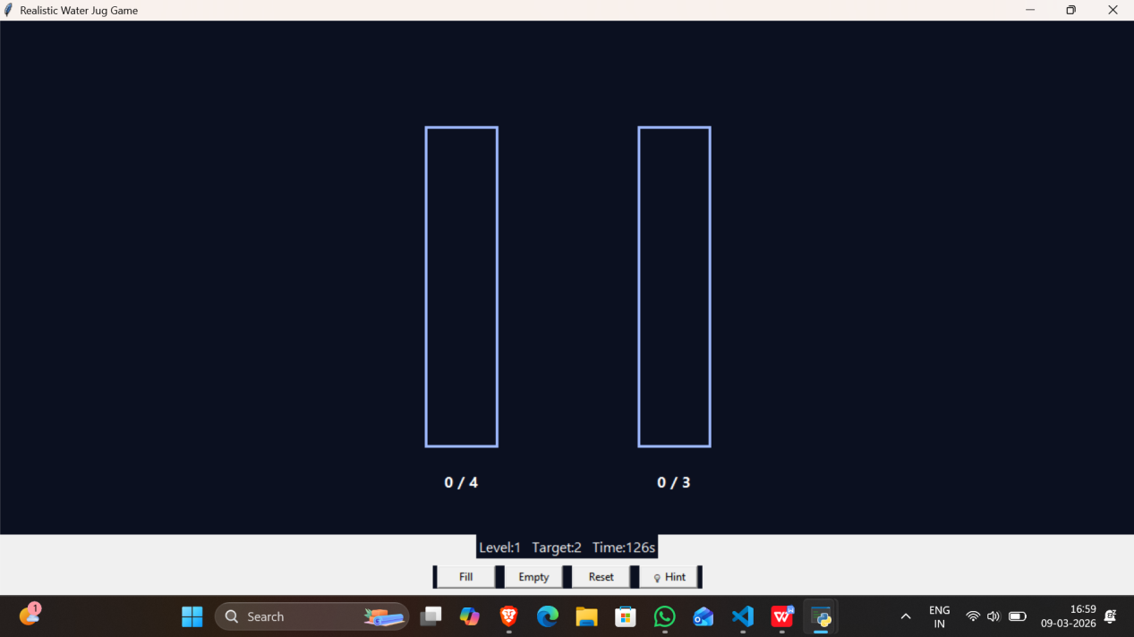

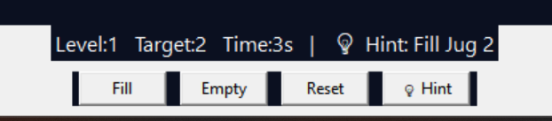
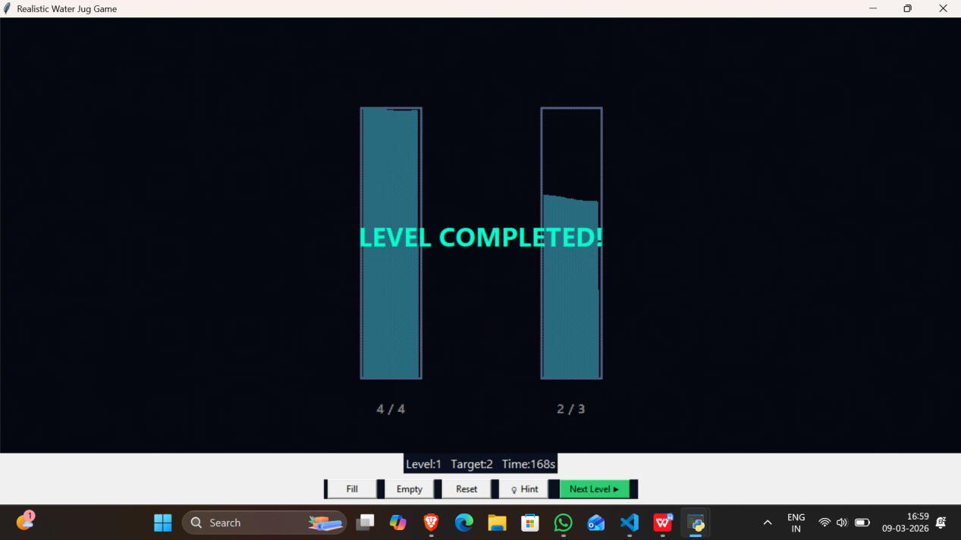

#Conclusion
The Water Jug Puzzle Game project shows how a traditional algorithmic problem can be changed into an interactive graphical application. The main goal of the project was to simulate the famous Water Jug Problem with a user-friendly graphical interface, while also using algorithmic logic to help users solve the puzzle.

The application was built using Python and the Tkinter GUI framework. In this project, concepts like event-driven programming, graphical user interface design, animation, and algorithm implementation were explored and combined into one application. Users can interact with two water jugs, perform tasks like filling, emptying, and pouring water, and see the results through animated water levels.

A key feature of the application is the smart hint system, which uses the Breadth-First Search (BFS) algorithm. This algorithm looks at the current state of the puzzle and suggests the next best move needed to reach the target amount of water. By using this algorithm, the project shows how artificial intelligence techniques can solve real-world logical problems.

The game also has multiple levels with different jug capacities and target values, which makes the puzzle more complex and encourages users to think critically about different strategies. The responsive full-screen layout, smooth pouring animations, and clear level progression all enhance user engagement.

Overall, this project illustrates how traditional computer science problems can create educational and interactive applications. It emphasizes important programming concepts like state-space representation, search algorithms, user interface design, and problem-solving strategies. The Water Jug Puzzle Game acts as both a learning tool for understanding algorithmic logic and a fun puzzle application.

Future improvements could include adding more levels with higher complexity, integrating sound effects and better visual animations, implementing score tracking and leaderboards, and possibly turning the application into a web-based or mobile platform for broader accessibility.

